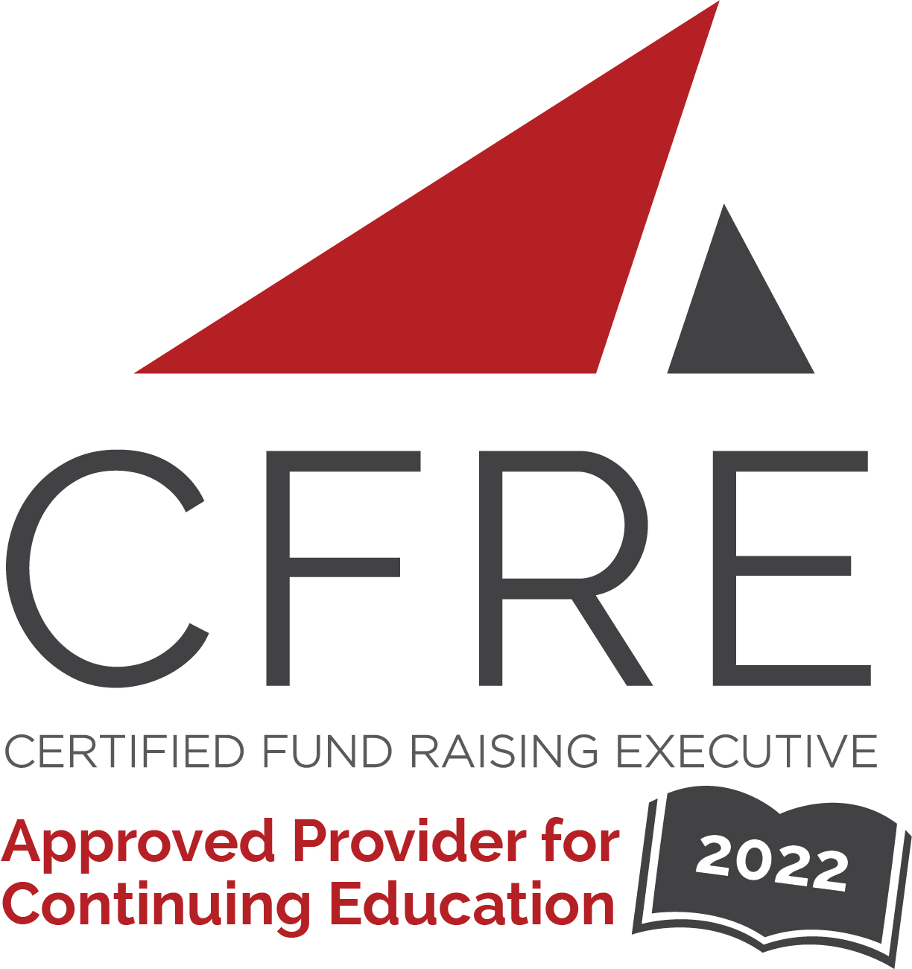  CFRE International has developed this form as a way for you to quickly track (and keep in your files!) the continuing education sessions you have attended. Simply check the boxes next to the sessions you attended. At the end of the conference, add up the total number of hours. Keep this sheet and you will be ready to complete your application form. All of the session slots listed are eligible for continuing education points on your CFRE application for initial certification and/or recertification. Sessions not listed here are not eligible for points. |  | CONTINUING EDUCATION POINTS TRACKER

Activity Organizer: - AFP Houston
Title of Activity: - 2022 Ask The Experts Conference
Names of Presenter(s): - Various
Dates and Location: - 16 June, 2022 – Houston, TX USA

Date: 16 July, 2022
8:45am – 10:15am (1.5 pts)
- Opening Keynote - Time to Own Our Awesomeness: Unleashing the Full Power of Nonprofit and Philanthropy

Date: 16 June, 2022
Session 1: 10:30am – 11:30am (1 pt)
- Capital Campaign Planning: From Fundraising to Construction and Architecture
- It’s Time To Elevate!
- Listening Session: AFP Global’s Fundraiser Bill of Rights
- The Importance of a Compelling Case

Date: 16 June, 2022
12:15pm – 1:15pm (1 pt)
- Afternoon Keynote: The State of the Nonprofit Profession

Date: 16 June, 2022
Session 2: 1:15pm – 2:15pm (1 pt)
- Using AFP International Data to Enhance Your Fundraising Effectiveness
- Mentoring New Board Members to Build Board Culture
- Updating Gift Acceptance Policies to Protect Your Organization and to Encourage the Right Gifts
- It’s 2022: Let’s Move Fundraiser Self-Care to the Top of the List

Date: 16 June, 2022
Session 3: 2:30pm – 3:30pm (1 pt)
- Using Data to Build a Robust Database at Every Level
- Navigating Agency Complexities & Practicing Equity Based Leadership
- Retention & Engagement in a Hybrid World
- Major Gifts in Small & Large Shops

Total number of points attained: __________

